Google Revenue Analysis (2014-24)

A Project Report Submitted By

Rohit Kumar – 2214110715
Sumit Singh - 2214110063
In partial fulfilment of the requirement For Project Based Learning of

BACHELOR OF TECHNOLOGY
In

COMPUTER SCIENCE & ENGINEERING
For
Google Revenue Analysis
Under the guidance of
Prof. Pratima Kadam



DEPARTMENT OF COMPUTER SCIENCE & ENGINEERING
BHARATI VIDYAPEETH (DEEMED TO BE UNIVERSITY) COLLEGE OF ENGINEERING, PUNE- 43
2024-25



BHARATI VIDYAPEETH (DEEMED TO BE UNIVERSITY) COLLEGE OF ENGINEERING, PUNE- 43

CERTIFICATE

This is to certify that the Project Based Learning report titled Google Revenue Analysis (From 2014 to 2024) , by Rohit Kumar, Sumit Singh to the Bharati Vidyapeeth (Deemed to be University), College of Engineering, Pune - 43 for the award of the degree of BACHELOR OF TECHNOLOGY in Computer Science & Engineering is a Bonafide record of the PBL work done by him/them under my supervision.

Place: Pune Name of Subject Teacher
Date: 09-04-2025 Sign………….………………
(Prof. Pratima Kadam)
Abstract

This project presents a comprehensive analysis of Google's revenue trends over the period from 2014 to 2024 using Power BI. The goal is to visualize, interpret, and derive insights from a decade of financial data to understand the company's growth trajectory, revenue streams, and market performance. The analysis includes segmentation by product lines such as Search, YouTube, Cloud, and Advertising, as well as geographic revenue distribution. Key performance indicators (KPIs), trend lines, year-over-year growth rates, and forecasting techniques are implemented to highlight critical financial patterns. Power BI’s interactive dashboards and visualizations enhance the interpretability of complex data, enabling users to explore relationships, identify key revenue drivers, and support strategic decision-making.
The dataset is curated from publicly available financial statements, ensuring data integrity and relevance. Data transformation and modeling processes are performed within Power BI to organize the information into a structured data model supporting efficient querying and visualization. Custom DAX measures are employed to calculate growth metrics, profit margins, and comparative performance across years and segments. Slicers and filters allow end-users to dynamically explore the data by year, region, or business segment.
Moreover, advanced forecasting techniques and visual trend analyses are incorporated to predict future performance based on historical patterns. These insights can assist stakeholders in evaluating Google's strategic investments, identifying periods of high growth, and understanding market behavior in response to global events such as the COVID-19 pandemic or technological shifts.
In conclusion, this project exemplifies the power of data visualization and analytics in driving corporate insight. It not only showcases Google's financial journey over ten years but also serves as a model for how business intelligence tools like Power BI can turn historical data into a valuable forecasting and decision-making resource.

Acknowledgement

I would like to express my sincere gratitude and appreciation to everyone who contributed to the success of this project-based learning.
Firstly, I would like to thank my project supervisor for providing valuable guidance and insights throughout the project. Your support and constructive feedback helped me to stay focused and motivated. I would also like to acknowledge the contribution of my fellow classmates who worked collaboratively with me on this project. Your creativity, commitment, and dedication were crucial to the success of this project.
I would like to thank the faculty members and administrative staff who provided us with the necessary resources and facilities to carry out this project-based learning.
Lastly, I would like to thank my family and friends who supported me throughout this journey, with their encouragement and motivation, I was able to achieve my goals.

Thank you all for your support and encouragement. This project-based learning experience has been an enriching and fulfilling one that I will cherish for years to come

Index

Sr.No. | Title | Page No.
 | Profile | 1
 | Certificate | 2
 | Acknowledgement | 3
 | Abstract | 4
 | Index | 5
 | Introduction | 6
 | Justification of Google Revenue Analysis | 7
 | Literature Study | 8-9
 | Use of Hardware and Software | 10
 | Advantages and Disadvantages | 11-13
 | Application of Topic | 14-15
 | Diagram of Project | 16
 | Output of the Program | 17
 | Conclusion | 18

- Introduction of Topic
In the modern business environment, data is one of the most valuable assets an organization can leverage. With the growing complexity of global markets, the ability to interpret financial performance over time is crucial for making informed decisions. Among the leading companies in the world of technology and digital services, Google (under Alphabet Inc.) has maintained its dominance through innovation, scalability, and strategic expansion. From its core business in online advertising to emerging segments like cloud computing and hardware, Google's revenue streams have diversified significantly between 2014 and 2024.
This project, titled "Google Revenue Analysis (2014–2024)", focuses on analyzing the company's revenue trends over the past decade using Microsoft Power BI, a powerful and widely-used business intelligence (BI) platform. The project aims to explore how Google’s revenue has evolved, identify which business segments and regions contributed most to growth, and uncover patterns that reflect broader technological and market changes.
The significance of this analysis lies not just in understanding Google’s financial performance but also in showcasing how BI tools can simplify complex datasets and provide actionable insights. By integrating financial data into Power BI, we are able to build interactive dashboards and visual reports that help users view the data from multiple perspectives — including yearly comparisons, segment-wise revenue breakdowns, regional contributions, and growth forecasting.
This type of analysis can benefit a wide range of audiences, from business analysts and students to investors and decision-makers, offering a holistic view of how one of the most influential tech giants adapted and scaled in response to changing demands, competition, and global events (e.g., the COVID-19 pandemic, regulatory shifts, and increased focus on cloud infrastructure and AI).
The motivation behind this project is two-fold: to gain practical experience in applying Power BI to real-world financial data and to gain deeper insights into Google’s financial journey. By the end of this project, readers and users will not only have a better understanding of Google’s revenue structure but also appreciate the value of data visualization in financial analytics.
- Justification of Topic

The selection of the topic "Google Revenue Analysis (2014–2024)" is justified by several key factors that highlight its relevance, value, and practical application in both academic and industry settings.
Firstly, Google is one of the most influential and financially successful technology companies globally, with a diversified portfolio spanning advertising, cloud services, hardware, artificial intelligence, and more. Analyzing its revenue patterns offers valuable insights into how modern tech companies grow, adapt, and innovate in response to evolving market demands.
Secondly, the period from 2014 to 2024 marks a decade of significant transformation in the digital world — including the rise of mobile computing, cloud adoption, remote work trends, and rapid advancements in AI. This makes it a compelling timeframe to assess how Google's business strategies and investments have influenced its revenue growth across different segments.
Thirdly, this topic provides an excellent opportunity to demonstrate the practical use of Power BI in handling real-world business data. Power BI is one of the most widely adopted tools in the field of business intelligence and data analytics. By applying it to Google’s financial data, the project bridges the gap between theoretical knowledge and practical implementation, enhancing skills in data modeling, visualization, and interactive reporting.
Moreover, the project fosters critical thinking and data-driven decision-making, as it involves identifying trends, patterns, and anomalies within large datasets. These skills are increasingly important in today's data-centric job market, particularly in roles related to data analysis, business strategy, and financial planning.
Lastly, analyzing Google’s revenue over time serves as a case study for understanding broader trends in the global tech industry, including monetization strategies, market competition, and the impact of global events like economic slowdowns or regulatory changes.
In conclusion, this topic is not only timely and relevant but also educationally enriching, offering deep insights into both a leading global corporation and the practical application of advanced analytics tools like Power BI.
- Literature Study of Topic

The revenue generation strategies and financial growth of tech giants like Google (Alphabet Inc.) have long been subjects of economic, business, and technological research. This literature study explores the key areas relevant to understanding the revenue dynamics of Google from 2014 to 2024, focusing on diverse income streams such as advertising, cloud services, subscriptions, and other sources.

1. Revenue Trends and Growth Analysis
Over the past decade, Google has exhibited consistent and significant growth in its annual revenue. Various scholarly and industry reports, such as those from Statista, Forbes, and Alphabet’s Annual Reports, reveal a strong upward trend driven primarily by online advertising, which has remained the dominant source of income. According to Alphabet’s financial disclosures, advertising made up over 80% of its total revenue throughout this period, indicating the strength of Google Ads as a platform for digital marketing.

2. Diversification of Revenue Streams
Recent studies (e.g., PwC Technology Outlook 2023) emphasize Google’s strategic shift toward diversification. Cloud services (Google Cloud), YouTube monetization, and subscription-based services (e.g., YouTube Premium, Google One) have emerged as important growth areas. This shift reflects Alphabet's efforts to reduce dependency on ad revenue and to tap into recurring income models.

3. Cloud Computing and Enterprise Solutions
Google Cloud’s contribution to total revenue has grown steadily, especially post-2020. Literature from Gartner and IDC highlights that Google’s investment in infrastructure, AI services, and enterprise tools has enhanced its competitiveness in the cloud space, although it still trails behind AWS and Azure in market share. The rise in cloud revenue reflects broader industry trends and increased demand for scalable computing solutions.

4. Impact of Global Events
Several academic sources analyze the impact of events like the COVID-19 pandemic on digital services. For example, during 2020–2021, Google saw an increase in traffic and usage of YouTube, cloud tools (Google Meet, Google Docs), and online advertising, contributing to revenue spikes. Harvard Business Review articles have emphasized how companies like Alphabet adapted rapidly through digital transformation strategies.

5. Visualization and Analysis Tools
Business Intelligence (BI) tools like Power BI and Tableau are commonly used to visualize and analyze such large datasets, as seen in dashboards presenting revenue figures by year, segment, and category. Literature on data visualization (e.g., Few, 2012) stresses the importance of effective graphical representation in identifying trends, supporting strategic decisions, and communicating findings clearly.

6. Financial Performance Metrics
Key performance indicators such as Gross/Net Revenue Ratio (G/N Revenue), year-over-year (YoY) growth, and segment-wise contributions (ads, subscriptions, cloud, etc.) are widely used in literature for evaluating financial health. These metrics assist analysts and investors in understanding Alphabet’s performance over time.

- Use of Hardware and Software

- Microsoft Power BI
- Used as the primary tool for data visualization. Power BI enabled the creation of interactive dashboards and graphs to represent revenue trends, category-wise income, and year-over-year changes.
- Features utilized: Data import from Excel, bar and line charts, slicers, filters, and dashboards.
- Microsoft Excel
- Served as the initial platform for data entry, cleaning, and basic analysis before importing into Power BI.
- Used for: Organizing raw revenue data, performing calculations, and formatting for compatibility with Power BI.
- Web Browsers (Google Chrome / Edge)
- Used to access online data sources including:
  - Alphabet’s official annual reports
  - Market research websites (e.g., Statista, Forbes)
  - News and business analysis portals
- Microsoft Word
Used for the documentation of the project, including the literature study, methodology, results, and conclusion.

- Snipping Tool / Screenshot Tools
Used for capturing visuals of the Power BI dashboards to be included in the final report.
  - Advantages and Disadvantages

Advantages:

- Industry-Relevant Case Study:
  - Google is a prime example of a data-driven enterprise. Analyzing its revenue gives insights into how tech companies monetize digital products and services in a global market.

- Skill Development:
  - The project strengthens practical skills in business intelligence, including data extraction, transformation, loading (ETL), data modeling, and DAX (Data Analysis Expressions) for calculations.

- Visual Storytelling:
  - Power BI enables clear and compelling visual storytelling through dashboards, allowing users to identify trends, patterns, and key insights at a glance.

- Dynamic Data Interaction:
  - Users can interact with filters, slicers, and drill-down visuals to explore data from multiple perspectives, enhancing understanding and decision-making.

- Forecasting Capability:
  - Power BI's built-in forecasting tools help predict future trends based on historical data, making the analysis more forward-looking and strategic.

- Application Across Fields:
  - The methodology and tools used in this project can be applied to other companies or industries, making it a versatile learning experience.

- Bridges Academia and Industry:
  - The project aligns academic learning with industry practices, preparing students and professionals for real-world data analytics scenarios.
- Supports Strategic Thinking:
  - Understanding Google’s revenue composition enables users to think strategically about innovation, product-market fit, and regional expansion.

Disadvantages

- Incomplete Financial Transparency:
  - Google often aggregates revenue into broad segments. The lack of detailed public data on individual product lines may limit in-depth analysis.

- Time-Consuming Data Preparation:
  - Cleaning, organizing, and structuring 10 years of financial data can be time-intensive, especially for large datasets with inconsistent formats.

- Requires Technical Knowledge:
  - Effective use of Power BI requires knowledge of data modeling, relationships, DAX calculations, and data visualization best practices, which may be challenging for beginners.

- Tool Constraints:
  - While Power BI is excellent for visualization, it has limitations for advanced statistical analysis or machine learning, which require additional tools like Python or R.

- Potential for Misinterpretation:
  - Without proper context, visualizations can be misinterpreted. Users must understand business background and external factors affecting revenue (e.g., regulation, economic shifts).

- Static Snapshots (Without Live Data):
  - If the data is not live or updated in real-time, the analysis reflects only a historical snapshot and may not account for rapid business changes.

- Overemphasis on Visuals:
  - There’s a risk of focusing too much on aesthetics rather than the accuracy or depth of insights, especially if visual elements are not carefully designed.

- Dependence on External Data Sources:
  - The accuracy of the entire project relies on sourcing data from trustworthy and consistent sources. Misinformation or outdated data can skew the analysis.

  - Application of Topic .

The analysis of Google's revenue over a ten-year period using Power BI has numerous real-world applications across various domains such as business strategy, education, financial planning, and technology. This topic demonstrates how historical financial data, when properly visualized and analyzed, can inform decisions and drive insights that are relevant in both academic and professional contexts.

1. Business Strategy and Market Research
- Companies and business analysts can use the insights from this project to study how a tech giant like Google allocates resources, invests in innovation, and grows its revenue across multiple services.
- It serves as a benchmark for market positioning, competitive analysis, and understanding revenue diversification strategies in the tech sector.

2. Financial and Investment Analysis
- Investors and financial planners can assess Google's performance over time, identifying stable or high-growth segments to support long-term investment decisions.
- Revenue trends and forecasting help in evaluating company value, earnings potential, and risk analysis.

3. Academic and Educational Use
- The project serves as an educational case study for students learning about business analytics, financial modeling, or data visualization.
- It demonstrates how tools like Power BI can be integrated into curriculum to teach data storytelling, BI report development, and analytical thinking.

4. Decision-Making and Forecasting
- The forecasting models built into the analysis can help stakeholders predict future performance, aiding in budgeting, planning, and strategic goal setting.
- Decision-makers in similar industries can use this project as a framework for analyzing their own revenue structures.

5. Business Intelligence and Reporting
- Organizations can adopt similar dashboard structures to monitor their internal financial data in real-time, leading to improved reporting, performance monitoring, and KPIs tracking.
- This application promotes data-driven culture within businesses.

6. Product and Segment Performance Evaluation
- By breaking down revenue by product lines (e.g., Search, YouTube, Cloud), the project shows how each business unit performs over time.
- This segmentation approach can be used by other companies to assess which products or services are driving revenue growth.

7. Trend Identification and Historical Analysis
- The analysis helps uncover macro and microeconomic trends affecting digital businesses — such as increased cloud adoption, advertising shifts, or the rise of mobile and video content.
- It also shows how external factors like the COVID-19 pandemic or regulatory actions impact revenue.

8. Competitive Intelligence
- Startups and other tech companies can analyze Google's strategies to understand market demands, find gaps in the industry, and identify opportunities for innovation or disruption.

Diagram of Project

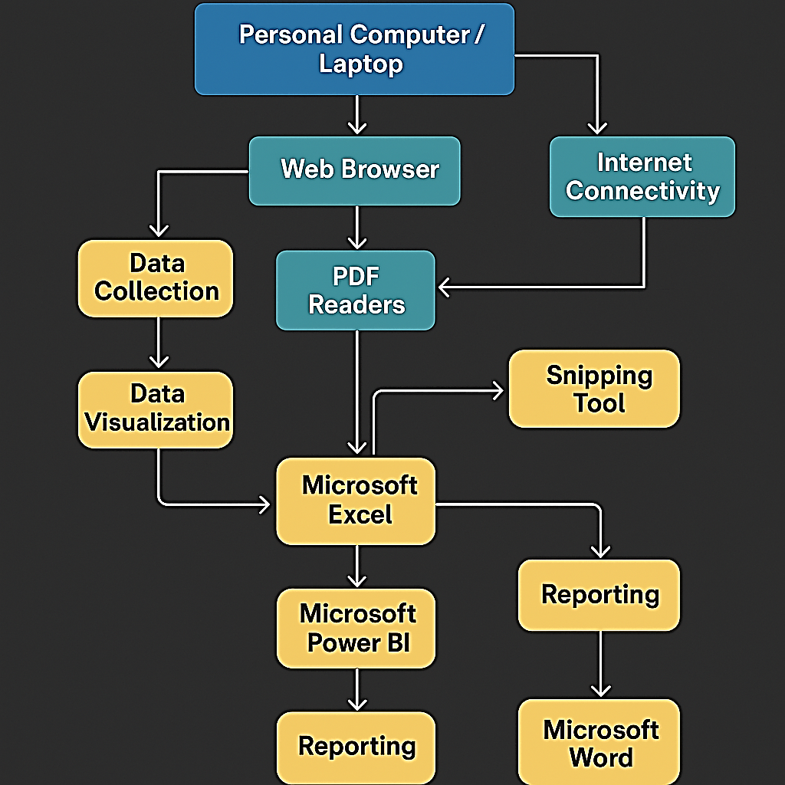

Output
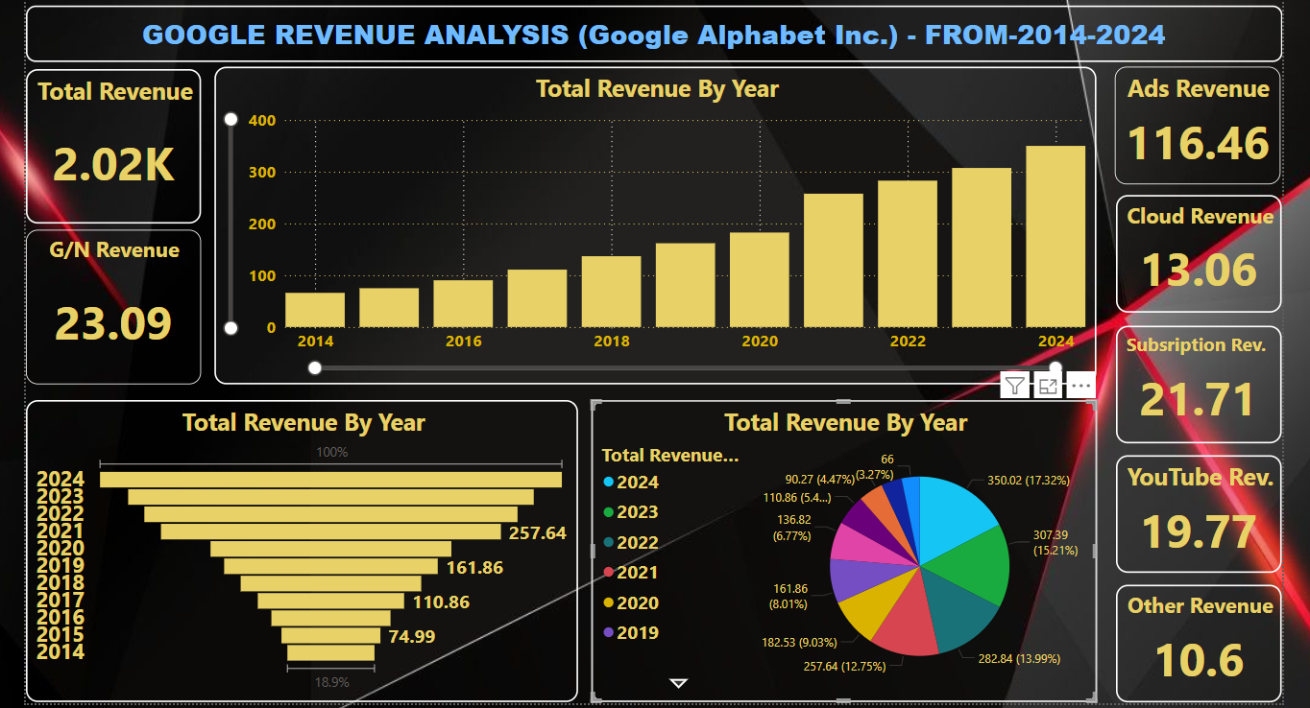

Conclusion

The Google Revenue Analysis (2014–2024) project offers a comprehensive view of one of the world’s most influential technology companies through the lens of data analytics and business intelligence. By leveraging the powerful features of Microsoft Power BI, this analysis transforms a decade of financial data into meaningful insights that highlight Google's growth patterns, business diversification, and market dominance.
Through interactive dashboards, visualizations, and trend forecasting, the project demonstrates how different revenue streams — such as advertising, YouTube, Google Cloud, and other services — have evolved over time and contributed to the company's financial performance. The segmentation of data by region and product line allows for a granular understanding of what drives Google’s success and how it adapts to the changing dynamics of the digital economy.
This project not only enhances technical proficiency in Power BI but also fosters analytical thinking and data-driven decision-making skills. It bridges academic learning with real-world application, providing value to students, analysts, investors, and business professionals alike.
In conclusion, the project underscores the importance of business intelligence tools in modern financial analysis. It proves that with the right data and tools, organizations can unlock hidden insights, support strategic planning, and forecast future opportunities more effectively. As the digital world continues to evolve, such analytical approaches will become even more critical in navigating business complexity and achieving long-term success.

